**General market review**

* Fitness penetration rate has grow to 15.6% in UK at 2019 , 1 in every 7 people is a member of a gym.
* over the 12 month period to the end of March 2019, fitness facilities increased by 2.9%, from 7038 to 7239, 4.7% increase in total number of members to 10.4million and 4.2% in market value to 5.1 billion
* 215 new fitness facilities opened in the last 12 months, down from 275 in 2018.
* 3.3 million members paying an average fee of £30
* Fitness Social Media Index looking at brands on Facebook, Twitter, Instagram and YouTube. The results don’t make for good reading: four of the top 10 private brands and nine of the top 10 public brands don’t use Instagram. Compare this to the active wear brands that have taken fitness beyond the gym to become a lifestyle.

**Membership retention:**

* it costs nine times as much to acquire a new member as it does to retain an existing one.
* In general: increasing member retention rates by 5% increased profits by between 25% and 95%. This is because 1. They refer more friends to your company, 2. They’ll often pay a premium to continue to do business with you rather than switch to a competitor
* However they haven’t specify how they calculated membership retention rate in their report. In below is a general formula

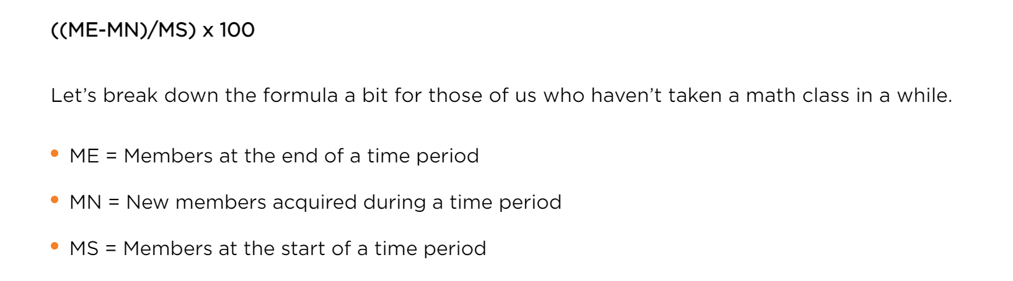

* A Group Fitness Model Leads to Higher Retention Rates:
  + from 2012 to 2015, memberships in traditional fitness clubs grew by just 5%, while the smaller specialty studios jumped by over 74%.
  + 18 to 25-year-old generation are more likely to attend fitness studios than other age groups. age 35 to 54-year-olds were more likely to attend traditional fitness facilities. Small specialised studio can also charge a higher price without scaring millennials away – class price are around $320 for 10 classes (USD)
  + the retention rate among fitness studios sits at 75.9% in 2018 and this number has been consistent since 2016. the retention rate of more traditional health clubs has sat at around 71.4%.
  + 85% of class members visit their facility twice a week specifically to engage in group classes. And 43% of members visit their facility four times per week for this purpose. Dr. Jinger Gottschall of Penn State University. Reviewing the impact of group fitness on exercises, the study examines a group of 25 adults between 25 and 40 who did not exercise regularly. The group contained 15 women and 10 men and they had to complete a 30-week group exercise program.

Group fitness study by Penn State University: during group study the intensity and regularity of the workouts increased every couple of weeks. There was a completion rate of 98.8%, meaning the subjects completed the majority of the classes they signed up for, something that has been unheard of in previous fitness studies.

* Strategies/implementation
  + Modify customer-acquisition incentives: Reward your sales teams and marketing channels for acquiring customers that stick. Consider reward for customer stay above 18 months.
  + Identify ways to help underperformers: take 360-degree survey, develop annual relationship report cards on clubs
  + Use the Internet: Make sure your Web site is so simple to use that many customers will prefer this faster and cheaper alternative – book gym session, get nutrition help, change membership, start membership etc, referring friend, transaction process etc.

Reallocate marketing investments: Systematically rank all of your customer acquisition campaigns on the basis of their yield of loyal customers. Shift resources towards programs that attract the richest mix of loyal customers.

* + Ensure that group fitness is offered at your club and that class content is updated regularly
  + Ensure there is a good variety of group fitness classes covering cardiovascular, strength and flexibility training
  + Be inclusive and support your members by starting slowly. Develop induction plans that allow your members to join a class for 20 minutes, rather than the whole hour for the first few weeks
  + Speak to your members regularly. Are there more classes you could be running or ones that aren’t well attended?

https://www.healthclubmanagement.co.uk/health-club-management-features/Research-round-up-Shaping-up/30442

https://www.clubindustry.com/sponsored/research-shows-group-exercise-key-to-member-retention

[https://www.glofox.com/blog/the-gym-membership-retention-statistics-worth-retaining-in-2019/ https://www.cnbc.com/2017/08/23/we-tried-some-of-the-most-popular-fitness-classes-in-nyc-heres-what-we-found.html](https://www.glofox.com/blog/the-gym-membership-retention-statistics-worth-retaining-in-2019/%20https://www.cnbc.com/2017/08/23/we-tried-some-of-the-most-popular-fitness-classes-in-nyc-heres-what-we-found.html)

https://media.bain.com/Images/BB_Prescription_cutting_costs.pdf

<https://www.wsj.com/articles/malls-never-wanted-gyms-now-they-court-them-1511697600>

**State of the Fitness Industry Report**